Scenario 1:

(SLIDE 1)This is Susan. She gives out fruit to children every day.



(SLIDE 2)Here is what she has on Monday. She has apples, pears, bananas, and oranges. She always brings more than enough. The leftover fruit are put in the middle.

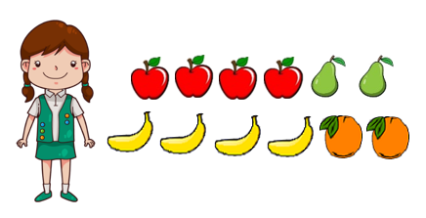

(SLIDE 3)e.g. Click on the boy that has some of Susan’s apples.

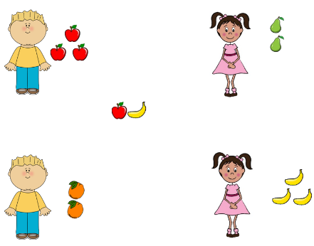

(SLIDE 4)Here is what she has on Tuesday.

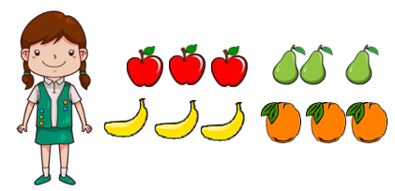

(SLIDE 5)e.g. Click on the boy that has some of Susan’s oranges.

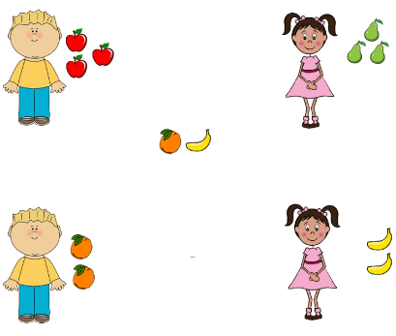

Scenario 2:

This is Michael. He gives out stationary to children every day.

Here is what he has on Monday. He has scissors, pencils, erasers, and rulers. The leftover items are put in the middle.

Here is what he has on Tuesday.

Scenario 3:

This is Amy. She gives out kitchenware to children every day.

Here is what she has on Monday. She has plates, forks, spoons, and knives. The leftover items are put in the middle.

Here is what she has on Tuesday.